- Selecting the browning level
Grades | Bread type
1-3 | Thin bread slice
3-5 | General bread
5-6 | Frozen bread
- How to use the appliance
Set the control knob to the suitable position, put the bread slice into the toast slots (the thickness of the bread slice cannot be 15mm less than the width of the slot, otherwise, the slice cannot get stuck.) and press down the lever, then the toaster begins to toast. As soon as the toasting cycle is completed (that is, the bread has been exactly browned as preset.), the slices of bread will automatically be ejected.
Suggestion:
Before first use it is suggested having the appliance without bread operated with the control knob set to grade 3 and the lever in down position to remove the heating element protection finish. At this time, the appliance will smoke. This is normal. It is recommended to have a good ventilation of air. After the first heating, let it cool down naturally before being used again.
Cleaning
- Before cleaning, switch off and unplug the appliance and have it cool down.
- Remove the crumbs from the browning slots and grids with the appliance not tilted. Then, open the door, clean away the crumbs and put the door back to the appliance.
- Clean away crumbs from toaster.
- Remove the crumbs from the browning slots and grids with the appliance not tilted. Then, slide out the tray, clean it and put it again into the appliance.
Outside cleaning:
Clean the outside of the appliance gently with a damp and soft cloth, and then wipe it with a dry cloth. Never use steel wire, abrasive cloth or other caustic cleaning agents, as they will damage the finish of the appliance.
Maintenance
- It is not allowed to dismantle the appliance or change its cord by yourself. If there is any trouble with the appliance, please have it adjusted or repaired by service agency.
- During use, if any defect of the appliance is suspected, please take it to service agency or its authorized
service agency. They will check for customers without charge if the appliance can be used safely or not.

********************************************************************************************************

5

BREAD TOASTER

INSTRUCTION MANUAL

FOR
T-801

(Read the instruction manual carefully before
use and keep these instructions)

Thank you for your purchasing the products of our company. Before using the appliance, please read these instructions carefully.

1
Specifications
Product name: bread toaster
Rated parameters: AC220-240V / 50/60Hz , 700W

Important safeguards
When using electrical appliances, basic safety precautions should always be followed to prevent the risk of fire, electric shock, burns, or other injuries or damages. Please read all instructions before use.
- This appliance can be used by children aged from 8 years and above and persons with reduced physical, sensory or mental capabilities or lack of experience and knowledge if they have been given supervision or instruction concerning use of the appliance in a safe way and understand the hazards involved. Children shall not play with the appliance. Cleaning and user maintenance shall not be made by children unless they are older than 8 and supervised.
- Keep the appliance and its cord out of reach of children less than 8 years
- Appliances are not intended to be operated by means of an external timer or separate remote-control system.
- Cleaning top surface:
Unplug from outlet and allow to cool before cleaning. Wipe the surface on the top of the bread slots with a damp cloth and dry it with another cloth or paper towel.
- Cleaning crumb tray:
The removable crumb tray is located at the bottom. Grasp the handle of the crumb tray and pull out completely. Dispose of crumbs and wash the tray in hot, sudsy water. Stubborn spots can be removed with a nylon mesh pad. The tray is not safe for dishwasher. Dry the tray thoroughly and naturally before re-inserting into its slot in the toaster.
Warning: Empty the crumb tray frequently. Crumbs will accumulate in the crumb tray and could catch fire if not emptied periodically.
- The outer surface may get hot when the appliance is operating.
- The bread may burn, therefore do not use the toaster near or below combustible material, such as curtains.
- If the supply cord is damaged, it must be replaced by the manufacturer or its service agent or a similarly qualified person in order to avoid a hazard.
- DO NOT touch hot surfaces.
- To protect against electrical shock, DO NOT immerse cord, plug, or any non-removable parts of this toaster in water or other liquid.
- DO NOT operate any appliance with a damaged cord or plug, or after the appliance malfunctions or has been damaged in any manner. Call the appropriate toll-free number for examination, repair, or adjustment.
- The use of accessory attachments not recommended or sold by the appliance manufacturer may cause injuries.
- DO NOT use outdoors. THIS APPLIANCE IS FOR HOUSEHOLD USE ONLY.
- NEVER let cord hang over edge of table or counter or touch hot surfaces.
- DO NOT place on or near a hot gas or electric burner, or in a heated oven.
- DO NOT use toaster for other than intended use.
- Oversized breads, metal foil packages, or utensils must not be inserted in a toaster, as they may create a fire or risk of electric shock.
- A fire may occur if the toaster is covered or near flammable material, including curtains, draperies, walls and the like, when in operation.
- DO NOT attempt to dislodge bread when toaster is plugged in.
- DO NOT operate toaster unattended.
- Risk of fire if the crumb tray is not cleaned regularly.
- DO NOT use metal scouring pads for cleaning. Pieces can get broken, and there is a risk of electric shock if the pad comes in contact with electrical parts.
- DO NOT cook, warm or toast rice cakes, fired breads or non-bread items.
- SAVE THESE INSTRUCTIONS.

INSTRUCTIONS FOR USE
- General description
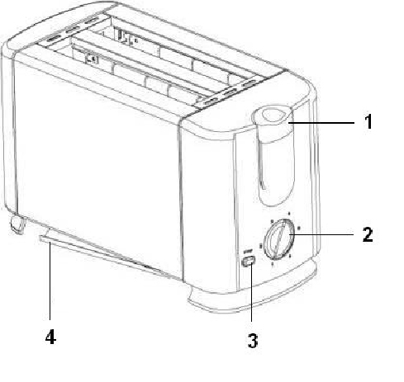

  - Carriage lever
Push down to start working
  - Timer set browning control
Bigger number for darker browning
  - Stop button
Push to cancel heating
  - Crumb Tray

3

